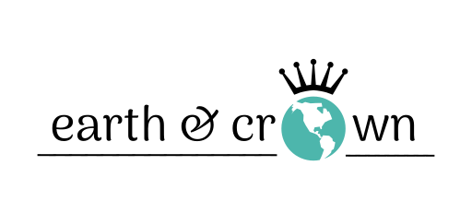
Consignment Information and Contract

Welcome! Thank you for choosing Earth & Crown to sell your merchandise. We are pleased that you want to become a part of our shop. Please read the following information carefully and complete the attached contract.

General Information

Dropping off: Please make an appointment with us by email
(earthandcrown@gmail.com) or by calling (250) 617-5423. At the appointment, drop off items for approximately 1 hour and take back items not selected for consignment sale.

Item Limits: Maximum 25 items per appointment.

Items Accepted: Laundered, quality, in-season clothing, shoes, and accessories in excellent condition. Designer, specialty, and cool vintage items are welcome; low-end items, intimate garments, and gym clothes, less welcome.

Promotion: Earth & Crown will make best efforts to promote the sale of merchandise through store placement, advertising, sales, and social media (such as Facebook and Instagram).

Consignment Period: 90 days; after this time, and unless specified in the contract, unclaimed items will become the property of Earth & Crown. Please see consignment contract for important information regarding discounting of items and pick-up of unsold items.

Pricing: We base prices on supply and demand. We will get the best possible price for you and will take your feedback into consideration. However, pricing is at the final discretion of Earth & Crown.

Payouts: You will receive 40% of the final selling price. If at any time you would like to check on the status of your account, stop by the store, call or email.

Ideally, we will pay you out for sold items at the end of the contract. We will try to accommodate earlier payout requests, but advance notice is appreciated. And, of course, you are welcome to use any credit owed to you on in-store purchases at any time during the consignment period.

Consignment Contract

On this day ______________________________________________, Earth & Crown and __________________________________ (“consignor”) do hereby enter into the following agreement:

- I hereby consign to Earth & Crown the merchandise listed on the inventory sheet.

- All my items will be on consignment for 90 days. I understand that my merchandise will be priced based on supply/demand at Earth & Crown’s discretion. Earth and Crown will have sales and promotions to encourage movement of merchandise.

- Unless specified otherwise (below), at the end of 90 days, unsold items become the property of Earth and Crown. Please read the following options carefully, and initial your choice:

Option 1: Initial _____

I agree to the above conditions and give over to Earth & Crown any remaining/unsold items at the expiry date of this contract. Earth & Crown, will exercise the right to donate, up-cycle, or further discount (e.g. $2 bin) the item(s).

Option 2: Initial _____

I would like to pick up my unsold items and I will contact Earth and Crown to make arrangements to do so before the expiry date of this contract. I understand that I have 14 days after the expiry date to pick up unsold items and that after this time, these items become the property of Earth & Crown.

- Although Earth & Crown will take the utmost care of my consigned pieces, the store does not cover losses to consigned property due to theft, damage, fire, flood, earthquake, apocalypse, or zombie invasion.

- I release Earth & Crown against any damage or loss of my item(s) while in possession of Earth & Crown.

I (“the consignor”) have read Earth & Crown’s Consignment Information and Contract. By signing below, I certify that I fully understand and agree to all of the Terms and Conditions in the contract.

Name: _____________________________________________

Phone: _____________________________________________

Email: _____________________________________________

____________________________________ ________________________
Signature Date

____________________________________ ________________________
Earth & Crown Signature Date

Contract Expiry Date: ______________________________

Consignor ID: ______________________________

