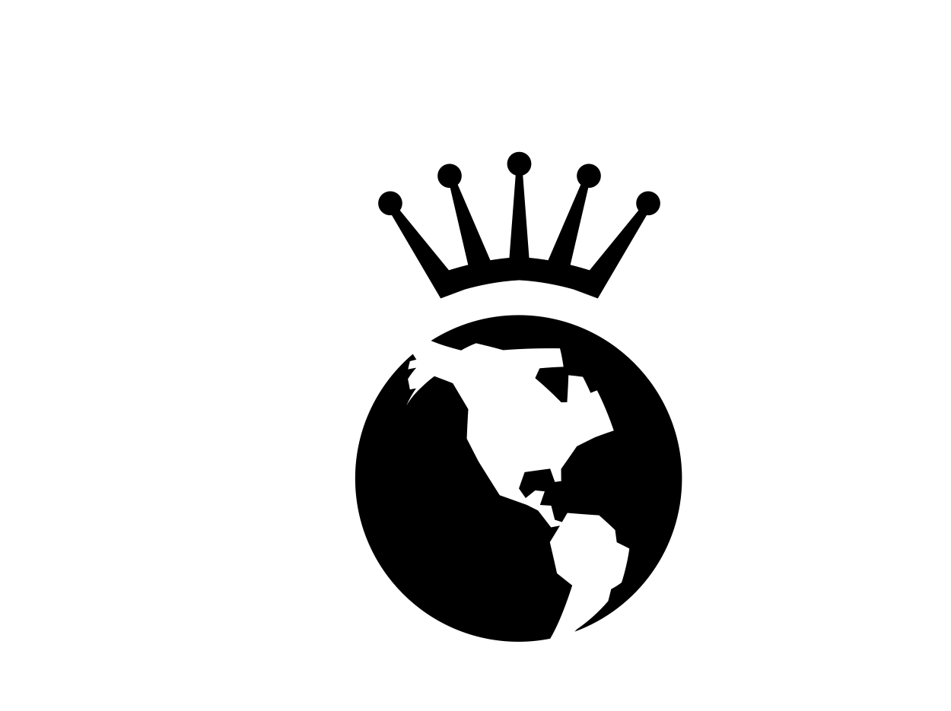
Artisan/Designer Consignment Agreement

Welcome! Thank you for choosing Earth & Crown to sell your art and designs. We are pleased that you want to become a part of our shop. Please read the following contract carefully, complete required information, and sign and date.

On this day, __________________________________________, Earth & Crown and
I, _________________________________________ (full name), do hereby enter into the following agreement I understand that by signing the contract I am agreeing to all terms and conditions listed below.

Consignment Inventory
Earth & Crown shall document receipt of individual pieces. I will sign off on the inventory list and maintain a copy for my records. Additional lists may be incorporated into the agreement if signed by both parties.

Pricing and Commission
I (artist) will set the price for each artwork/design piece; this pricing will be documented on the inventory list. I agree that Earth & Crown’s commission is 30% of the retail price. Earth and Crown will provide a price tag and codes for inventory. Initial Here _________

Duration of Contract and Payment
I will be paid by Earth & Crown at the end of the 3-month contract. At this time, Earth & Crown and I will review sells and discuss discount options. I may decide to discount some or all items within a new contract.

Responsibility of Loss or Damage
Although Earth & Crown will take the utmost care of my art/design pieces, the store does not cover losses to consigned property due to theft, damage, fire, floods, apocalypse, or zombie invasion. I, however, may maintain insurance coverage at my own discretion.

Promotion
I will provide an informative post card and/or business card for my art/designs. This information will be reviewed and approved by Earth & Crown. Earth & Crown will also make best efforts to promote the sale of my art/designs through store placement, advertising, and social media.

Duration and Termination of Consignment

I agree that the consignment term for my artwork shall continue until ____________________ (end of three months). At the end of the contract, all accounts will be settled and unsold artwork/designs will be returned to me.

______________________________________________ ___________________________
Signature of Artist/Designer Date

______________________________________________ ____________________________
Earth & Crown Signature Date

